Báo cáo bài tập tuần 1
Hoàng Đức Anh – 20235640

HelloWorld

Code :
import javax.swing.JOptionPane;

public class HelloWorld {
public static void main(String[] args) {
String result;
result = JOptionPane.showInputDialog("Hi! What's your name?");
JOptionPane.showMessageDialog(null, "Hello " + result + "!");
System.exit(0);
}
}

Kết quả: 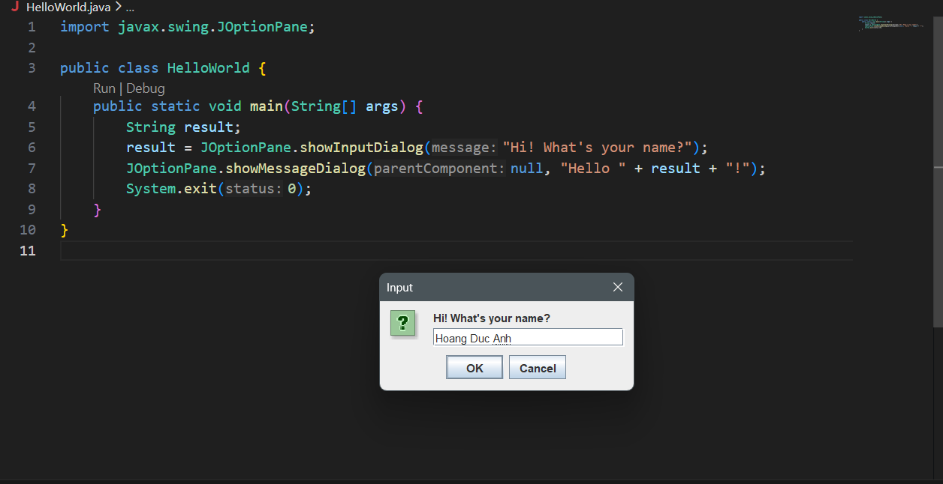

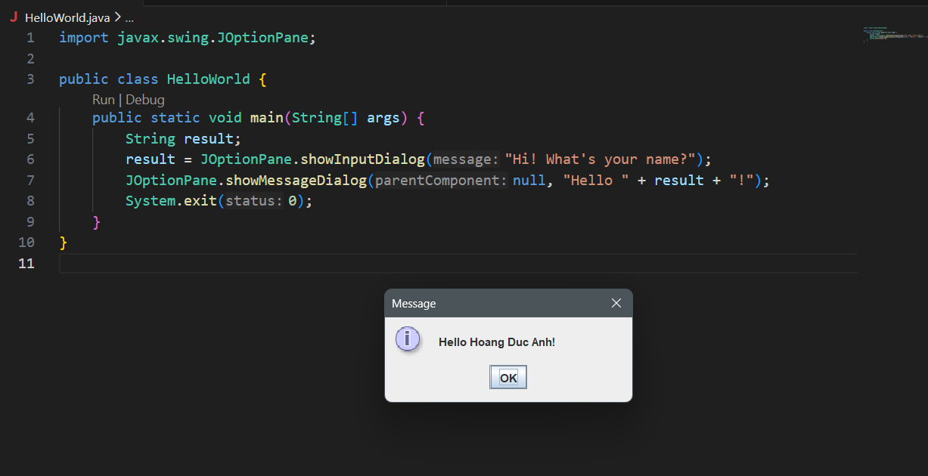

Calculator build by Swing

Code:
- CalculatorController:
package MVCSwing;

import java.awt.event.*;

public class CalculatorController {

private CalculatorModel model;
private CalculatorView view;

public CalculatorController(CalculatorModel model, CalculatorView view) {
this.model = model;
this.view = view;

view.btnCalculate.addActionListener(new ActionListener() {
public void actionPerformed(ActionEvent e) {
try {
int a = Integer.parseInt(view.txtA.getText());
int b = Integer.parseInt(view.txtB.getText());
String op = (String) view.cbOperator.getSelectedItem();

double result = model.calculate(a, b, op);
view.lblResult.setText("Result: " + result);

} catch (NumberFormatException ex) {
view.lblResult.setText("You need to enter 2 integers");
} catch (Exception ex) {
view.lblResult.setText("Error!");
}
}
});
}
}

- CalculatorMode:
package MVCSwing;
public class CalculatorModel {

public double calculate(double a, double b, String op) {
switch (op) {
case "+": return a + b;
case "-": return a - b;
case "*": return a * b;
case "/":
if (b != 0) return a / b;
else throw new ArithmeticException("Cannot divide by 0");
default: return 0;
}
}
}

- CalculatorView:
package MVCSwing;
import javax.swing.*;
import java.awt.*;

public class CalculatorView extends JFrame {

JTextField txtA = new JTextField(5);
JTextField txtB = new JTextField(5);
JComboBox<String> cbOperator = new JComboBox<>(new String[]{"+", "-", "*", "/"});
JButton btnCalculate = new JButton("Calculate");
JLabel lblResult = new JLabel("Result: ");

public CalculatorView() {
setTitle("Calculator - Swing MVC");
setLayout(new FlowLayout());
setSize(300,150);
setDefaultCloseOperation(EXIT_ON_CLOSE);

add(txtA);
add(cbOperator);
add(txtB);
add(btnCalculate);
add(lblResult);

setVisible(true);
}
}

- Main:
package MVCSwing;
public class Main {
public static void main(String[] args) {
CalculatorModel model = new CalculatorModel();
CalculatorView view = new CalculatorView();
new CalculatorController(model, view);
}
}

Kết quả:

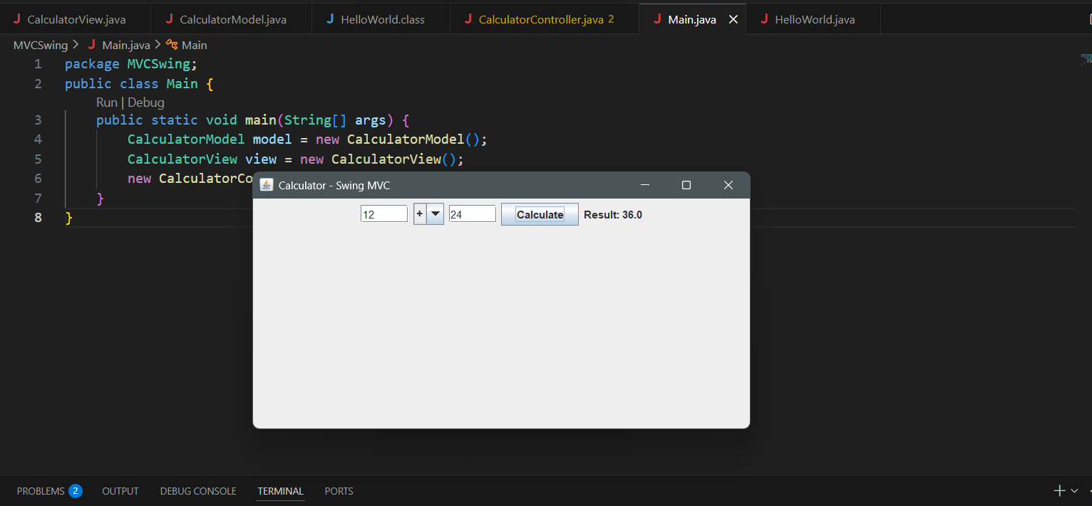
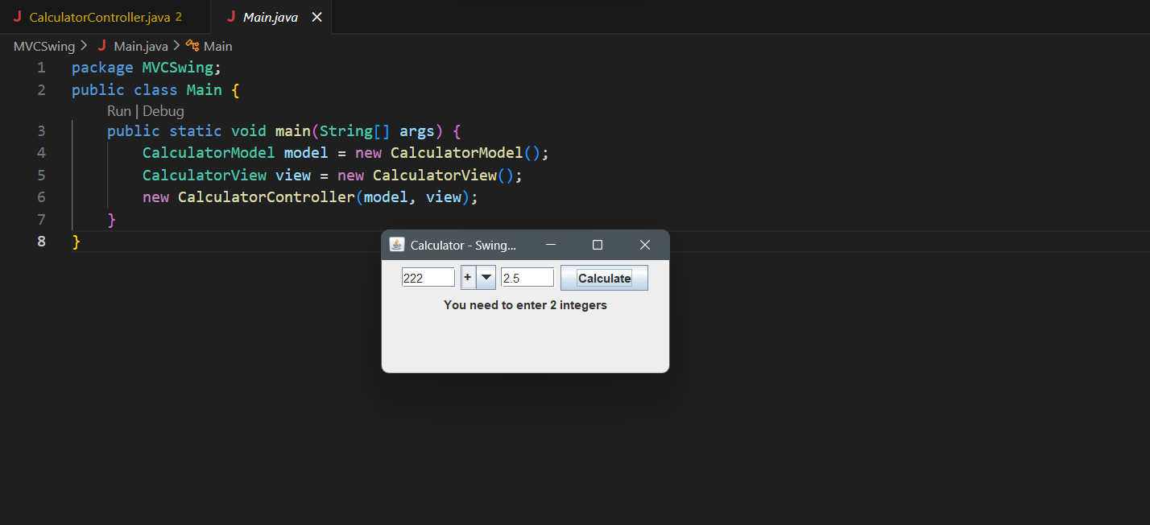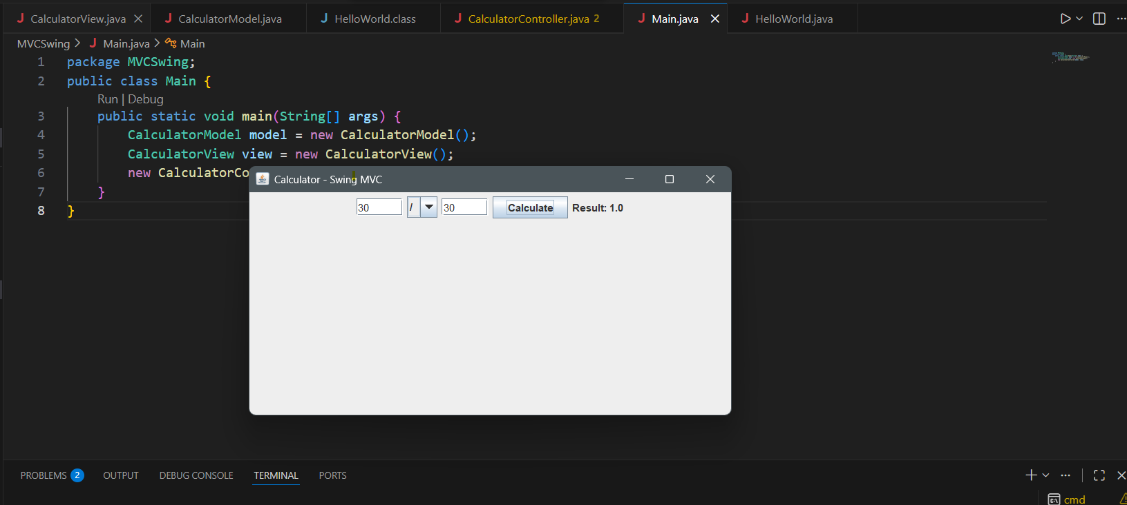

Calculator build by JavaFX

Code:
- Calculator.fxml
<?xml version="1.0" encoding="UTF-8"?>

<?import javafx.scene.control.*?>
<?import javafx.scene.layout.*?>

<VBox spacing="10" alignment="CENTER"
xmlns="http://javafx.com/javafx/17"
xmlns:fx="http://javafx.com/fxml"
fx:controller="CalculatorController">

<Label text="Calculator MVC" />

<TextField fx:id="txtA" promptText="Enter first integer"/>

<ComboBox fx:id="cbOperator"/>

<TextField fx:id="txtB" promptText="Enter second integer"/>

<Button text="Calculate" onAction="#handleCalculate"/>

<Label fx:id="lblResult" text="Result:"/>

</VBox>
- CalculatorController
package MVCJavaFX;

import javafx.fxml.FXML;
import javafx.scene.control.*;

public class CalculatorController {

@FXML
private TextField txtA;

@FXML
private TextField txtB;

@FXML
private ComboBox<String> cbOperator;

@FXML
private Label lblResult;

private CalculatorModel model = new CalculatorModel();

@FXML
public void initialize() {
cbOperator.getItems().addAll("+", "-", "*", "/");
cbOperator.setValue("+");
}

@FXML
private void handleCalculate() {

try {
int a = Integer.parseInt(txtA.getText());
int b = Integer.parseInt(txtB.getText());
String op = cbOperator.getValue();

double result = model.calculate(a, b, op);
lblResult.setText("Result: " + result);

} catch (NumberFormatException e) {
lblResult.setText("You need to enter 2 integers");
} catch (ArithmeticException e) {
lblResult.setText("Cannot divide by zero");
} catch (Exception e) {
lblResult.setText("Error!");
}
}
}

- CalculatorModel
package MVCJavaFX;

public class CalculatorModel {

public double calculate(int a, int b, String operator) {

switch (operator) {
case "+":
return a + b;
case "-":
return a - b;
case "*":
return a * b;
case "/":
if (b == 0) {
throw new ArithmeticException("Divide by zero");
}
return (double) a / b;
default:
throw new IllegalArgumentException("Invalid operator");
}
}
}

- Main
package MVCJavaFX;

import javafx.application.Application;
import javafx.fxml.FXMLLoader;
import javafx.scene.Scene;
import javafx.stage.Stage;

public class Main extends Application {

@Override
public void start(Stage stage) throws Exception {

FXMLLoader loader = new FXMLLoader(
getClass().getResource("calculator.fxml"));

Scene scene = new Scene(loader.load());

stage.setTitle("Calculator MVC");
stage.setScene(scene);
stage.show();
}

public static void main(String[] args) {
launch();
}
}

Kết quả:
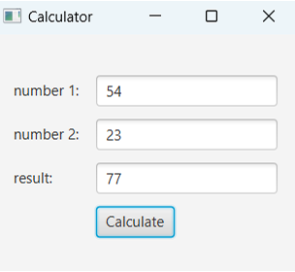
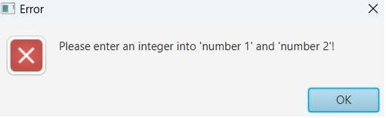

4.Git

Add
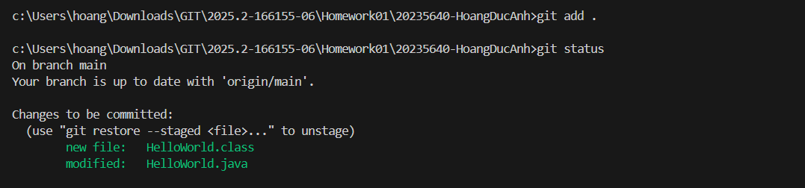

Remove
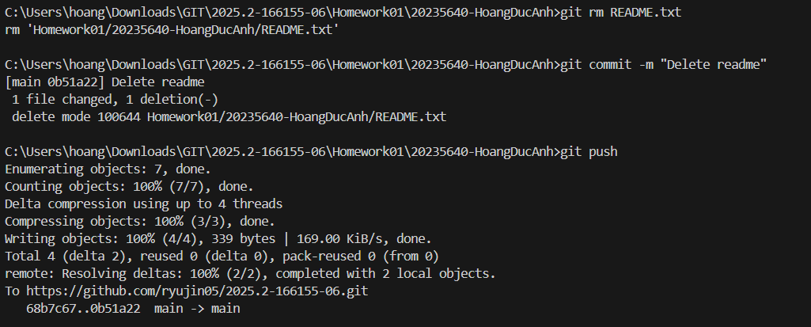

Modify
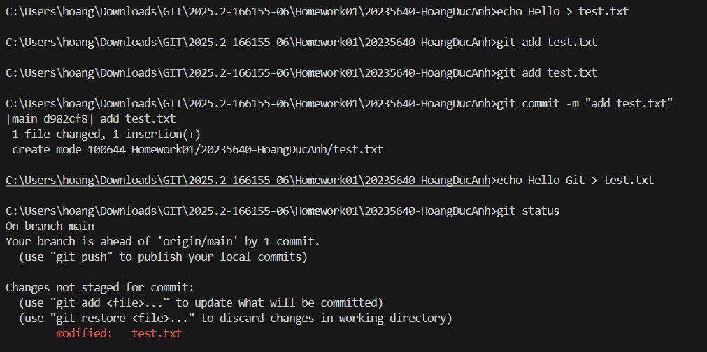

Commit
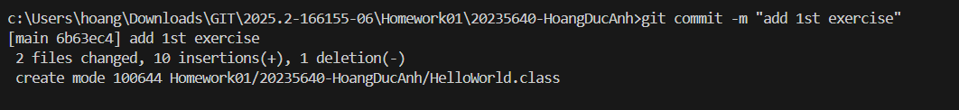

Push
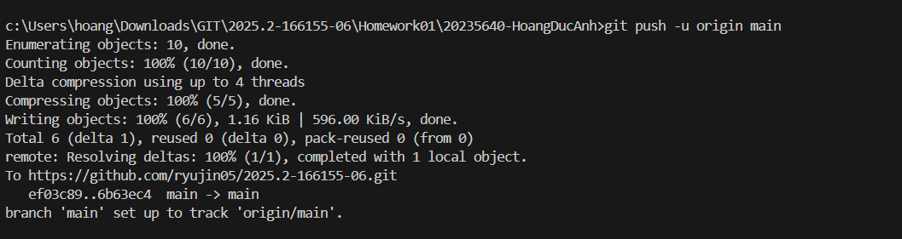

Pull
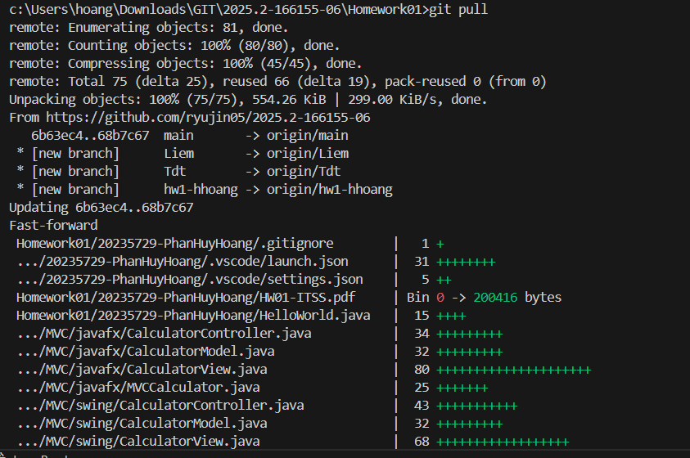

Merge
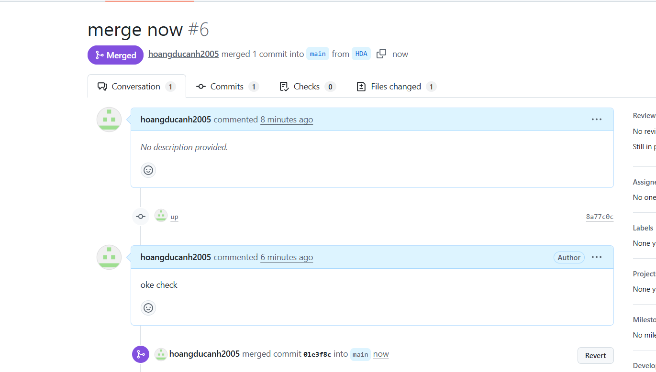

Branch
